Project Handover Document

**Company: Redback Operations**

Project: Oxygen Consumption

*Trimester 3, 2022*

Table of Contents

1. Project Information 3

1.1. Company Acting Director 3

1.2. Project Team 3

2. Project Overview 3

3. User Manual 3

4. Completed Deliverables 4

5. Roadmap 4

6. Open Issues 4

7. Lessons Learned 5

8. Product Development Life Cycle 5

8.1. New Tasks 5

8.2. Definition of Done 5

8.3. Task Review 6

8.4. Testing 6

8.5. Branching Strategy 6

9. Product Architecture 6

9.1. UML Diagram 6

9.2. Tech Stack 6

10. Source Code 7

11. Login Credentials 7

12. Other Relevant Information 7

13. Appendices 7

# Project Information

## Company Acting Director

**Akan Cosgun**

*Senior Lecturer, Emerging Technology Robotics*

[akan.cosgun@deakin.edu.au](mailto:akan.cosgun@deakin.edu.au)

## Project Team

**Project Name: Oxygen uptake prediction model**

Team Members: Andrew Mayes & Zhiyong Wu

# Project Overview

The following project aims to accurately predict oxygen consumption over a time interval given heart rate values. The motivation behind doing so is that accurate real time measures of oxygen consumption are expensive and impractical. Furthermore, analysis of oxygen consumption enhances the user experience by providing richer feedback on training sessions. Thus, creating a model that can predict accurately oxygen consumption is useful for enhancing product value and customer experience.

**[ZHIYONG WU - Insert stuff here]**

The project was divided into two work streams during the third semester:

1. Modify and improve the pre-existing model in order to create a lightweight, explainable and performant model.
2. [**ZHIYONG WU - Insert stuff here**]

# User Manual

Below provides a video explaining the code related to the updated model as well as other key points. In addition, there is a readme to accompany the video guide ,which is also useful when starting out.

1. Video Guide – [Click Here](https://youtu.be/DHPCkAqcQ9A)
2. Read Me – [Click Here](https://github.com/redbackoperations/data-analysis/tree/main/Trimester%203%202022/Project%202%20Oxygen%20uptake%20prediction%20model%20/Andrew)

Note: GitHub location may change over time, please update links.

**[ZHIYONG WU - Insert stuff here**]

# Completed Deliverables

Code Developed:

* Integrated Database
  + Three datasets combined into one.
  + GitHub Storage
* Data Pre-processing
  + Scaling techniques applied
  + Train-Test Splitting
  + Traceable IDs
* Model Optimisation
  + Grid search
  + Optimised hyperparameters
* Model Visualisation
  + Time series visualised

# Roadmap

Code Developed:

* Integrated Database
  + Change database location to redback operations GitHub
* Model Visualisation
  + Random Forest Visualisation
* Model Production
  + Save the trained model – [link](https://www.google.com/search?q=how+to+save+scikit+learn+model&oq=how+to+save+scik&aqs=chrome.0.0i512j69i57j0i22i30l8.4094j0j7&sourceid=chrome&ie=UTF-8)
  + Load the trained model - [link](https://www.google.com/search?q=how+to+save+scikit+learn+model&oq=how+to+save+scik&aqs=chrome.0.0i512j69i57j0i22i30l8.4094j0j7&sourceid=chrome&ie=UTF-8)
  + Create real time app

# Open Issues

# Lessons Learned

Under the section titled “What's already been tested” one can find various techniques and models that have been tested.

* [Click Here](https://github.com/redbackoperations/data-analysis/tree/main/Trimester%203%202022/Project%202%20Oxygen%20uptake%20prediction%20model%20/Andrew)

# Product Development Life Cycle

We work as a team and focus on delivering measurable values to the project and the company.

We have 3 daily stand-ups each week (start/mid/end of a week’s meeting) to sync the working progress between different team members. We discuss any issues and potential extra works we need to do for the project during the stand-ups. We’ve also had lots of ad-hoc chats in Teams app whenever we need a quick discussion.

We plan tasks in the [Trello board](https://trello.com/b/NSuF3z83/data-analytics) and indicate our progress from there. We create PRs frequently and get them merged timely by the team lead.

## New Tasks

We come up with new tasks along the way while we are working on existing planned tasks or from each stand-up meeting time. Any new tasks will be created in the [Trello board.](https://trello.com/b/NSuF3z83/data-analytics)

## Definition of Done

A DoD list is normally clearly defined in each Trello card, so the card assignee will be able to know exactly when a task is treated as completed by meeting all the DoD items. Additionally, we also have different status labels on each task on the Trello board to indicate their completeness.

## Task Review

Since only the team lead has the permission to merge a PR in GitHub, a task is treated as done when its associated PR is reviewed and merged by the team lead.

## Testing

We test this project merely using manual testing due to the intense time limit this term. While we doing a manual test for a task, we ensure all DoDs are met before marking it to be done.

## Branching Strategy

We never directly push any changes into the company’s `main` branch. To make any changes, we either create a new branch based off the latest `main` branch or fork the company’s `main` branch into our own repo. After we’ve finished the changes, we create a PR against the company’s `main` branch, and have it reviewed and merged by the team lead. We also ensure to resolve conflicts (if there’s any) before merging back to the latest `main` branch.

# Product Architecture

## UML Diagram

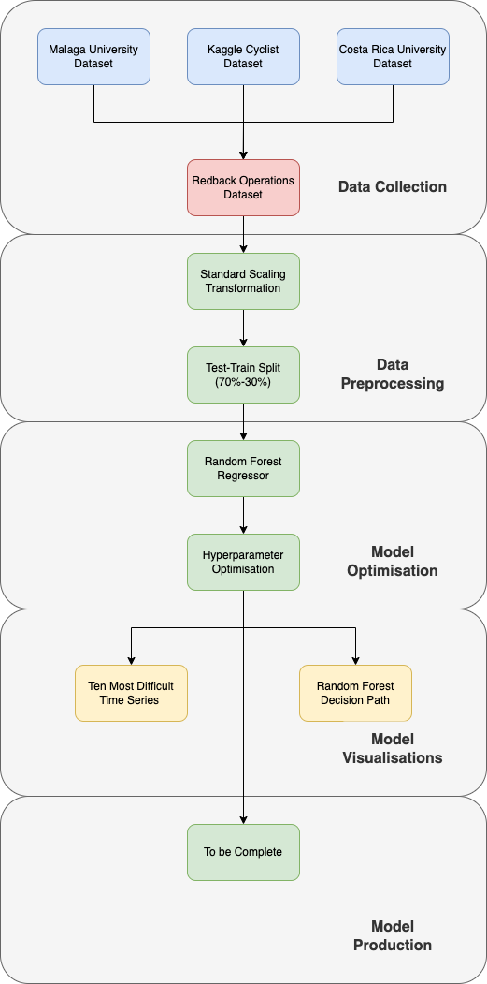

## Tech Stack

Python:

* One of the most popular programming languages in data science.
* Easy to learn programming language.
* Wide range of data science libraries.

Google Colab:

* Allows anybody to write and execute arbitrary python code through the browser.
* Shareable and interactive code.

GitHub:

* Online service for software development and version control using Git.
* Shareable and interactive code and documentation.

# Source Code

All source code can be found:

* [Click Here](https://github.com/redbackoperations/data-analysis/tree/main/Trimester%203%202022/Project%202%20Oxygen%20uptake%20prediction%20model%20/Andrew)

# Login Credentials

Redback Operations YouTube Channel:

* Email - [redback.operations.deakin@gmail.com](mailto:redback.operations.deakin@gmail.com)
* Password - Kucri*a!r&pA$r4tr&s?awRavUq0cE

# Other Relevant Information

# Appendices

Trimester Three – Trello Board:

* [Click Here](https://trello.com/b/NSuF3z83/data-analytics)

Trimester Three – Projects, Documentation and Everything Else:

* [Click Here](https://github.com/redbackoperations/data-analysis/tree/main/Trimester%203%202022)

All completed tasks/documents from T3 2022 can be found here: <https://github.com/redbackoperations/data-analysis/tree/main/Trimester%203%202022>